Open your first sketch

Open the LED blink example sketch: File > Examples >01.Basics > Blink.

Select your board type and port You’ll need to select the entry in the Tools > Board menu that corresponds to your Nano board. NOTE: First, make sure you have the Arduino AVR Core 1.16.21 or later looking at the Board Manager. Then, to program the NEW Arduino NANO boards you need to choose *Processor > "ATmega328P (Old Bootloader)"*. If you get an error while uploading or you are not sure which bootloader you have, try each type of processor 328P until your board gets properly programmed.

you need to choose *Processor > "ATmega328P (Old Bootloader)*

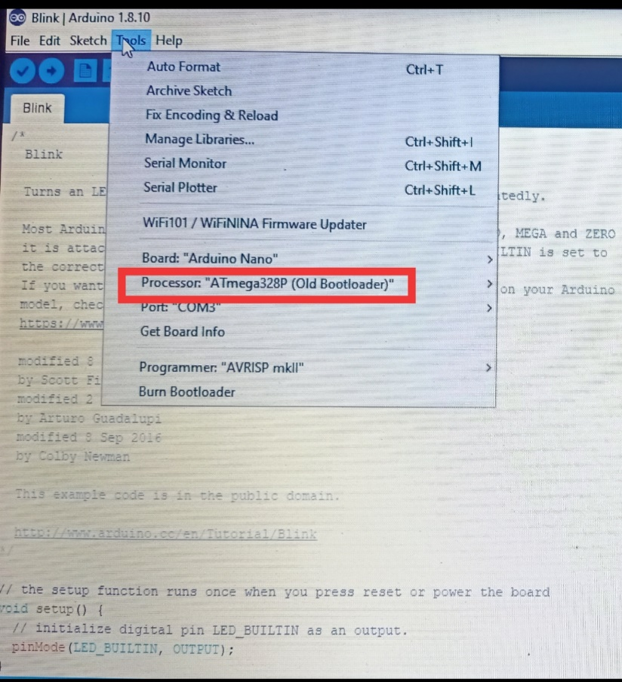

Upload and Run your first Sketch To upload the sketch to the Arduino Nano, click the Upload button in the upper left to load and run the sketch on your board:  
Wait a few seconds - you should see the RX and TX leds on the board flashing. If the upload is successful, the message "Done uploading." will appear in the status bar.

Board tested & work perfectly. IF any problem call us on 7738041183 or whatsapp. Before give any bad feedback.